

resolut A-in module Purpose and Characteristics

Module Resolut A-IN is intended for installation in audio processor Resolut and allows to connect analog outputs (linear and outputs to acoustic system).

- Number of analog inputs – 8 (linear or high-level)
- Мaximal signal on linear inputs – 3 V (RMS)
- Мaximal signal on high-level inputs – 45 V (RMS)
- Dynamical range of digital-analog conversion – 112 Db

Attention! You can group channels - for one part of input channels can be used as linear , second part - as high-level. But for each input channel you can use only one type of input - high-level or linear, not both!

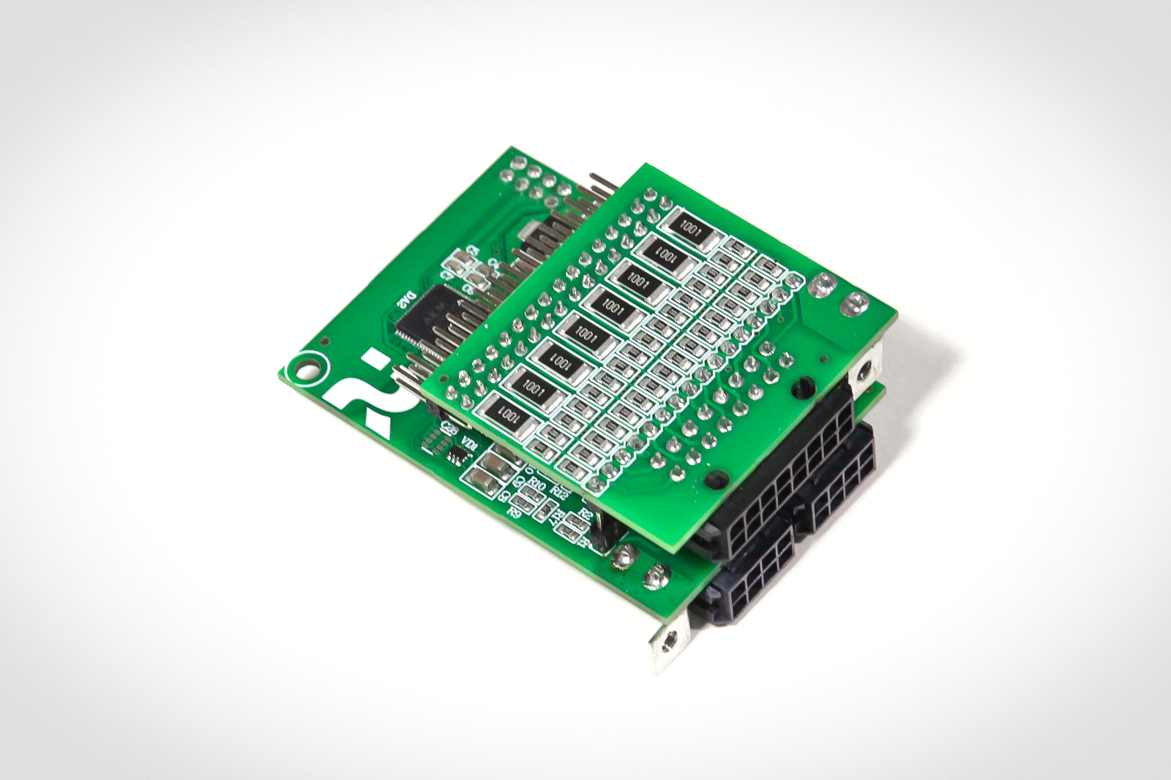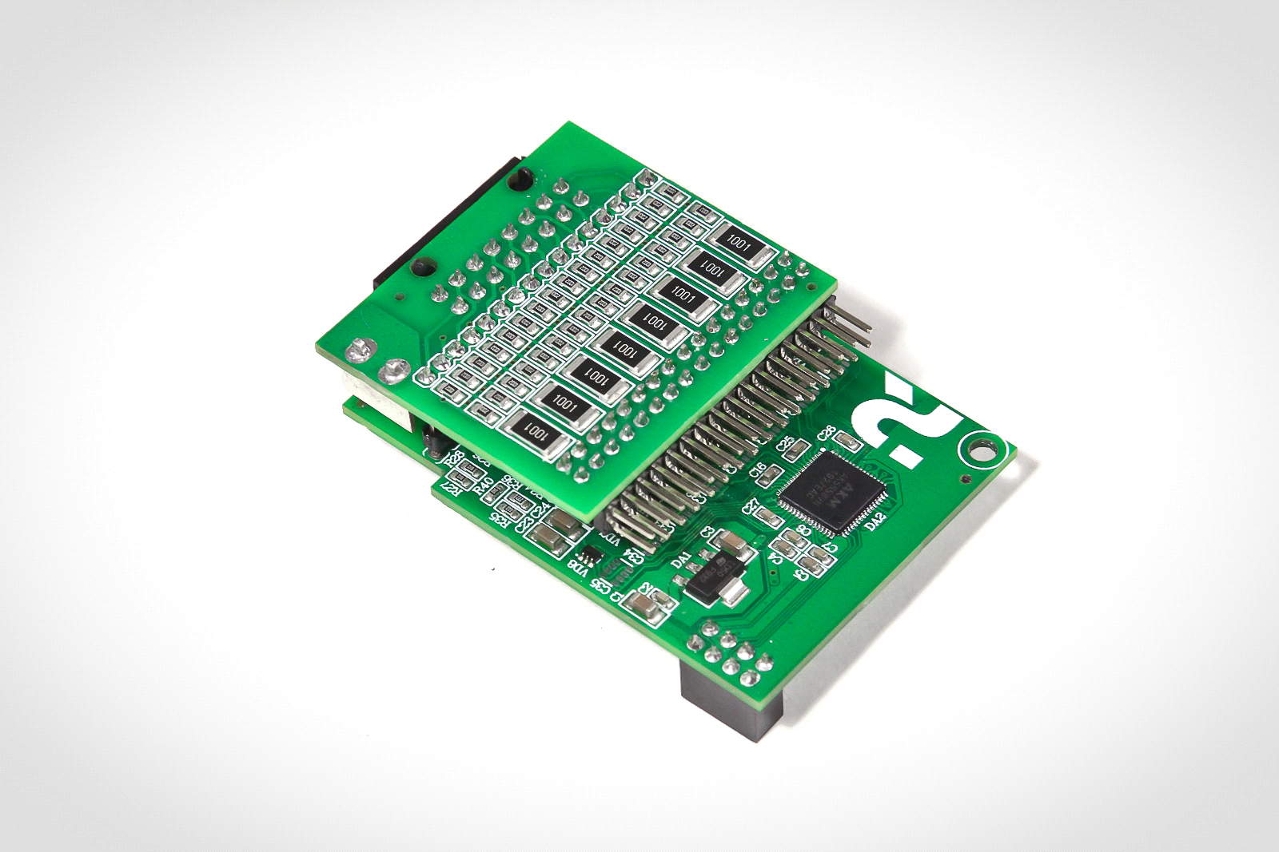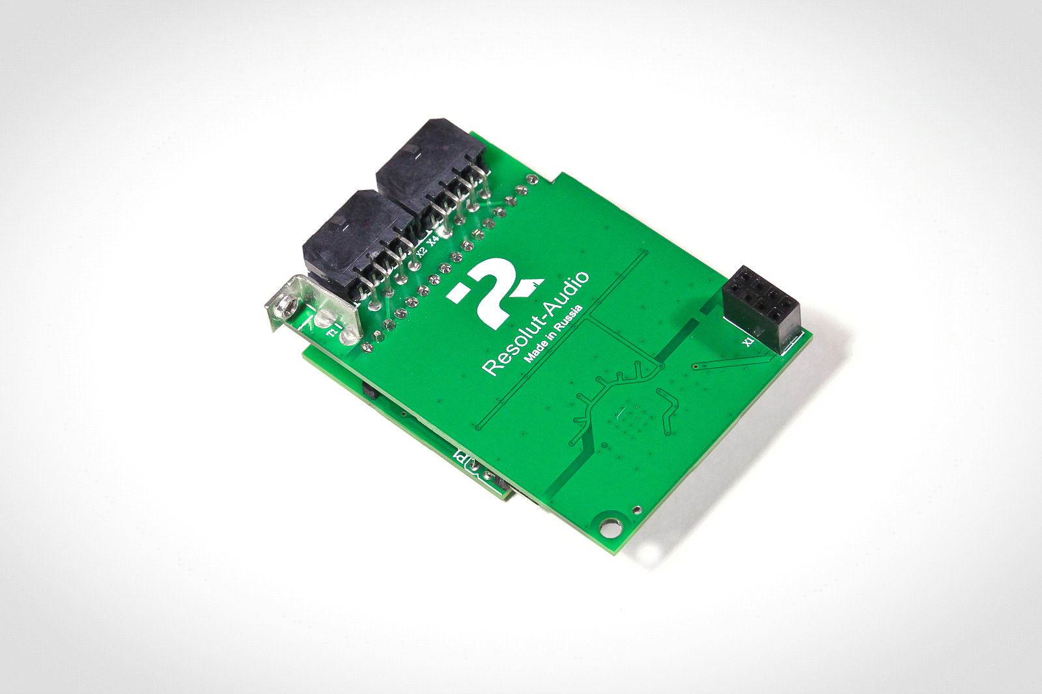

Conciliation. We are continuously improving our product therefore individual elements and details of appearance may differ from what you see on the photos.

Delivery set

- Оptional module Resolut A-IN – 1.
- Replacement panel for processor – 1.
- Connectors for linear and high-level inputs – 1.

INSTALLATION MANUAL resolut a-in module

Step 1. For installation of module remove four screws on top cover and screws on face panel. Remove cover and panel.

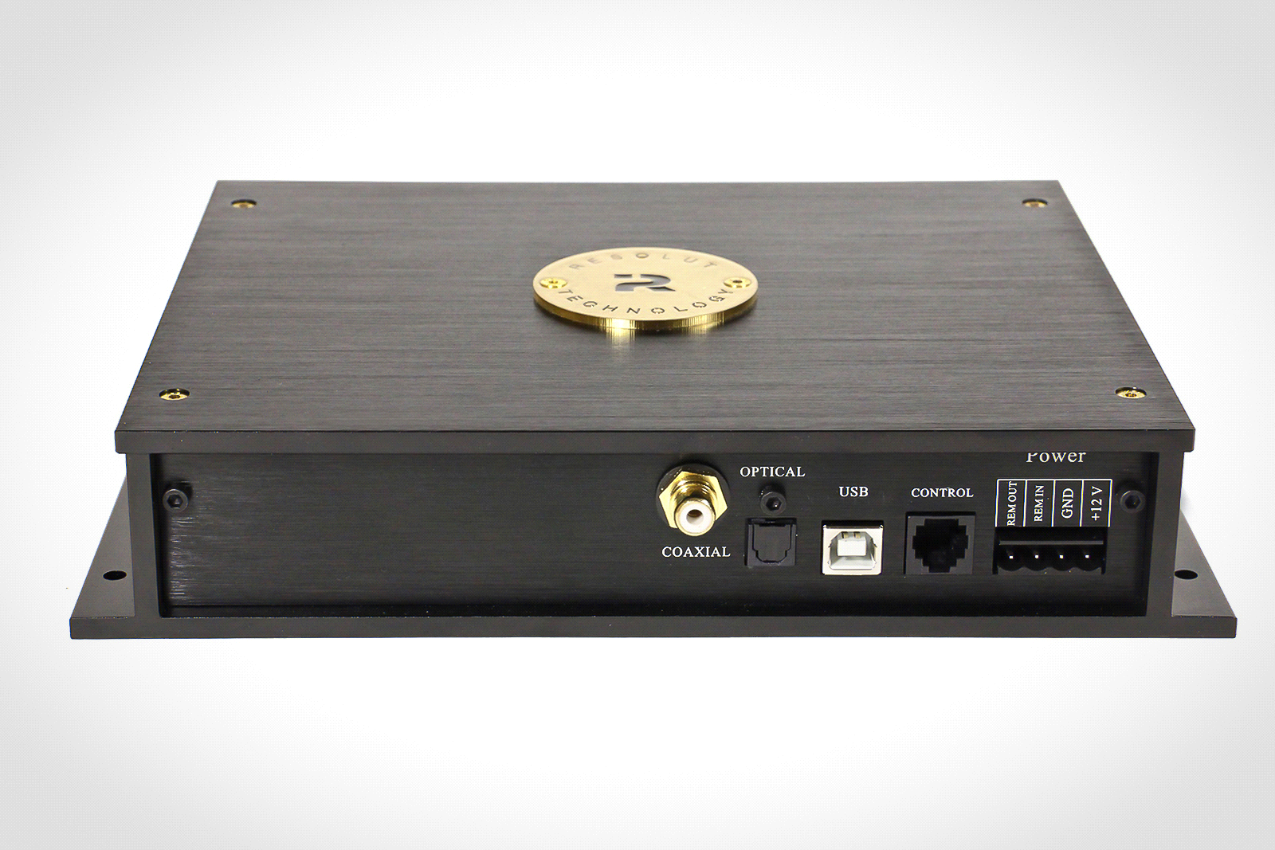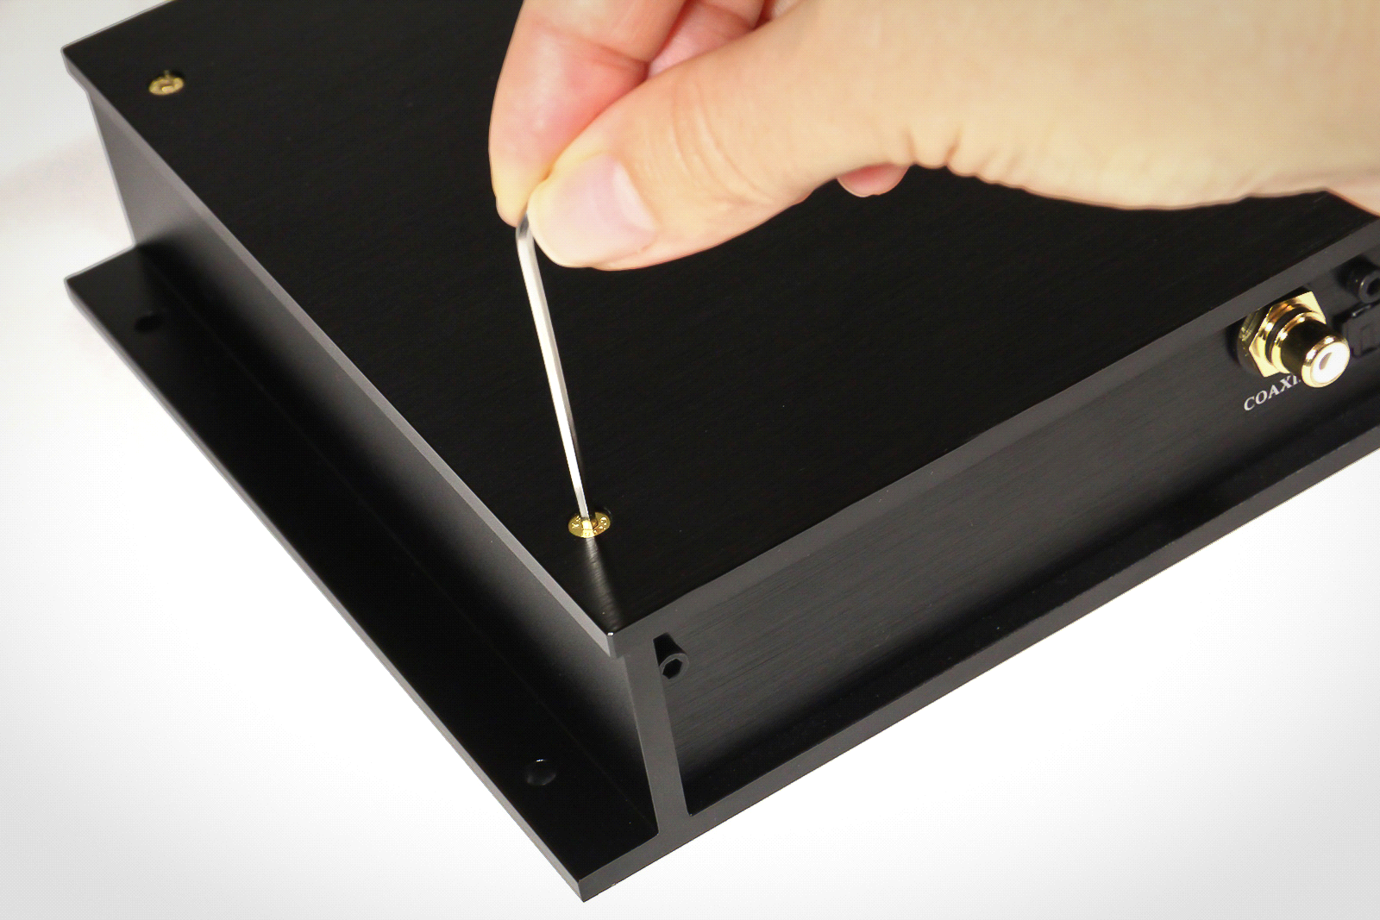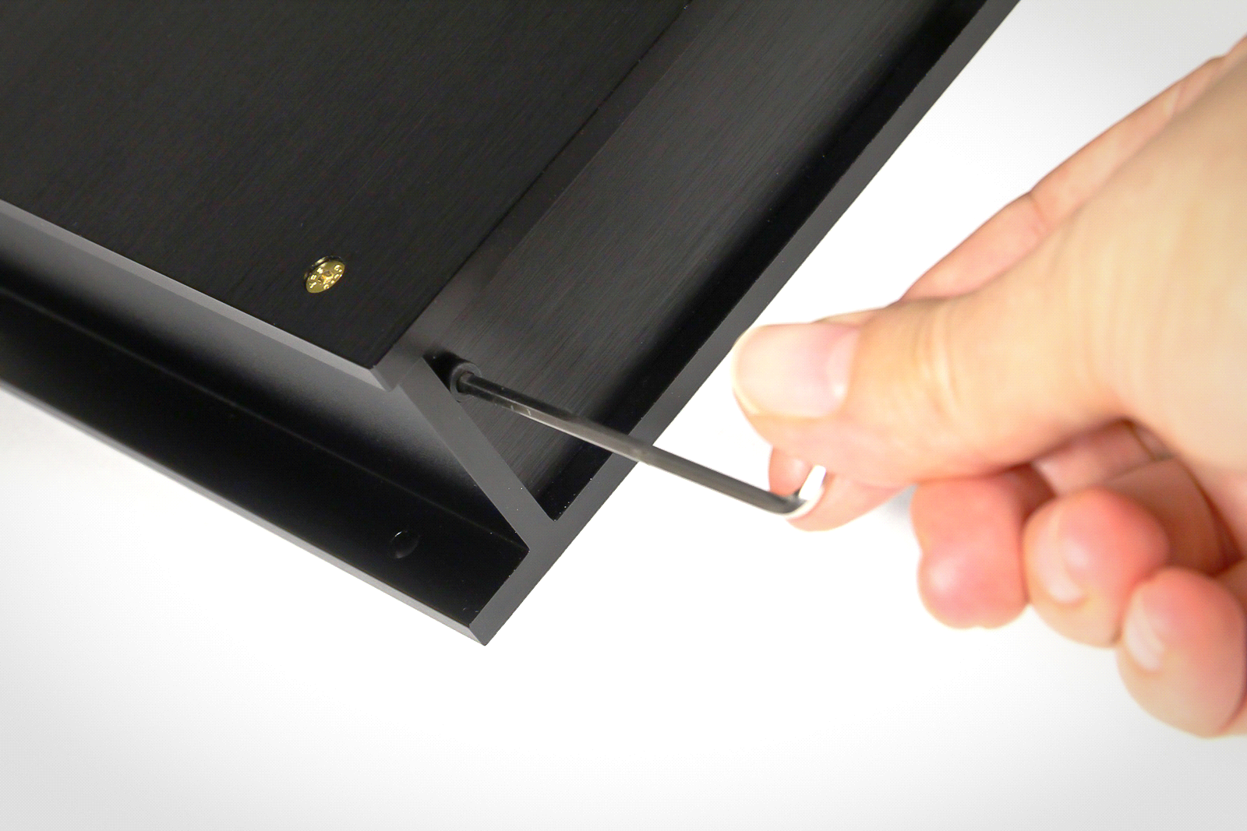

Further base panel will be changed by replacement panel from delivery set.

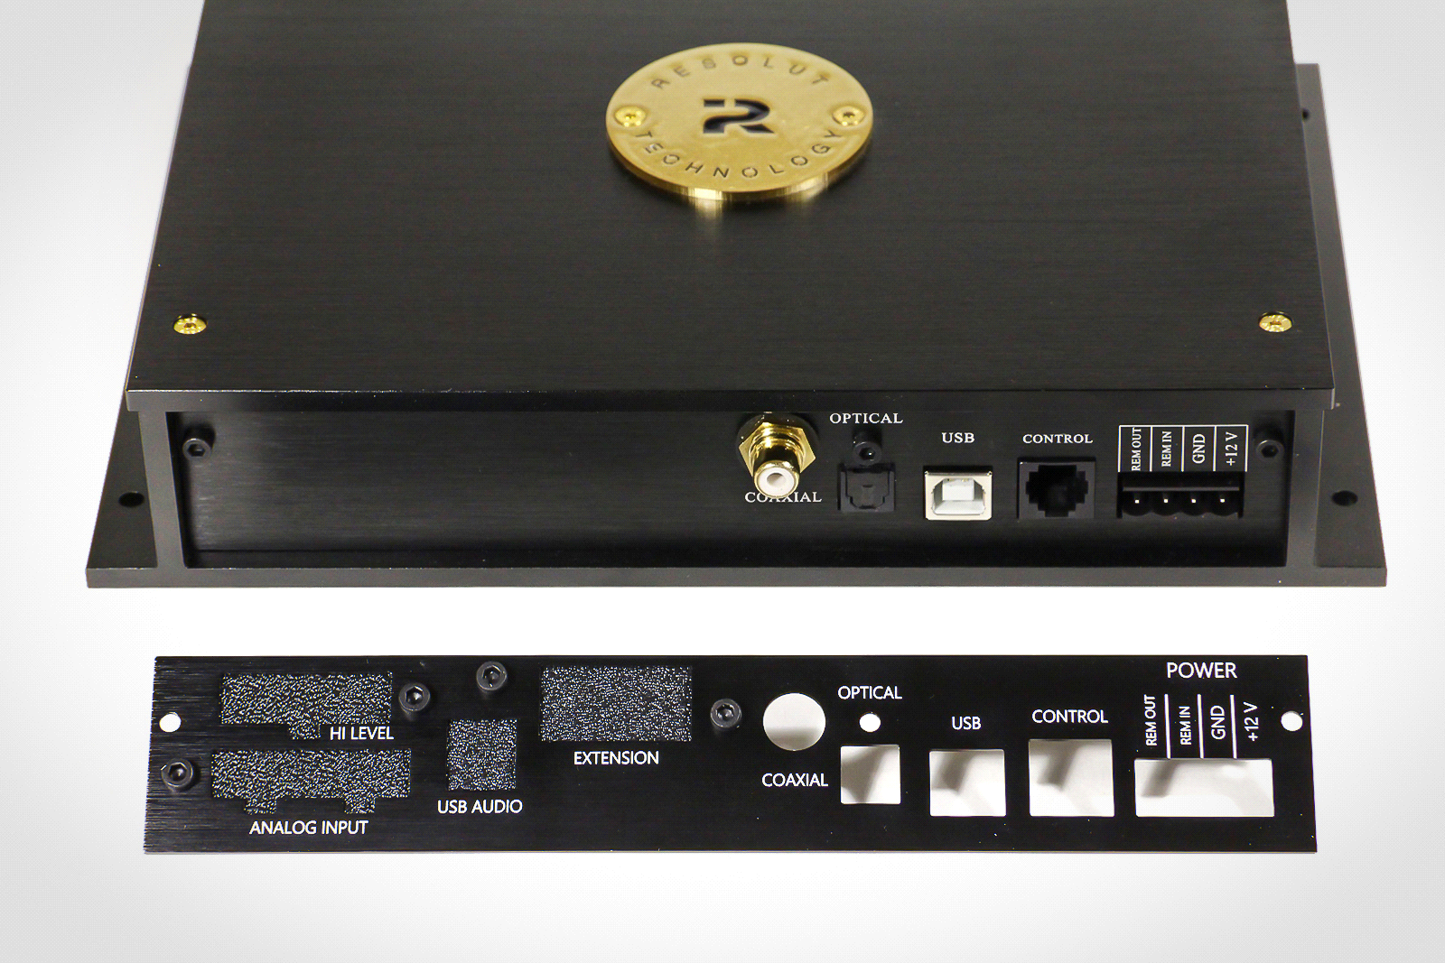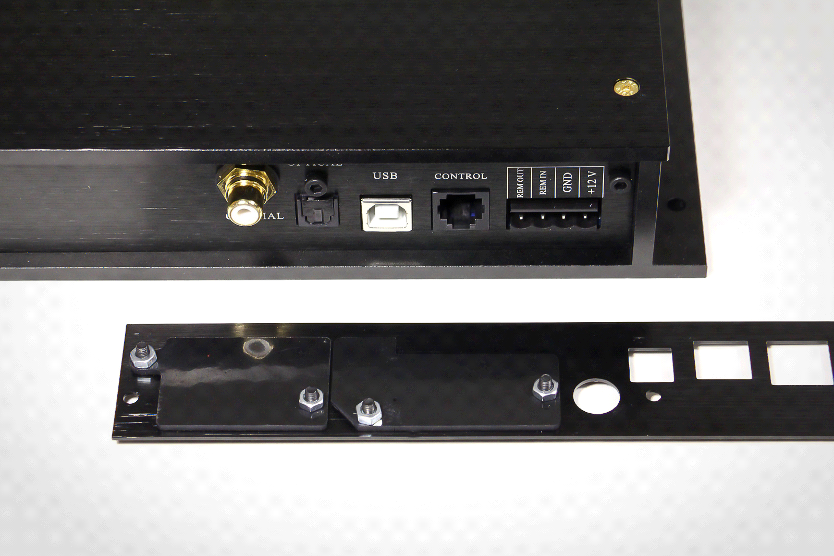

Step 2. Carefully disconnect digital coaxial input from the board. Please note order the wires are connected to board, further wires must be connected the same way. Remove connector with base panel and replace it to a new panel.

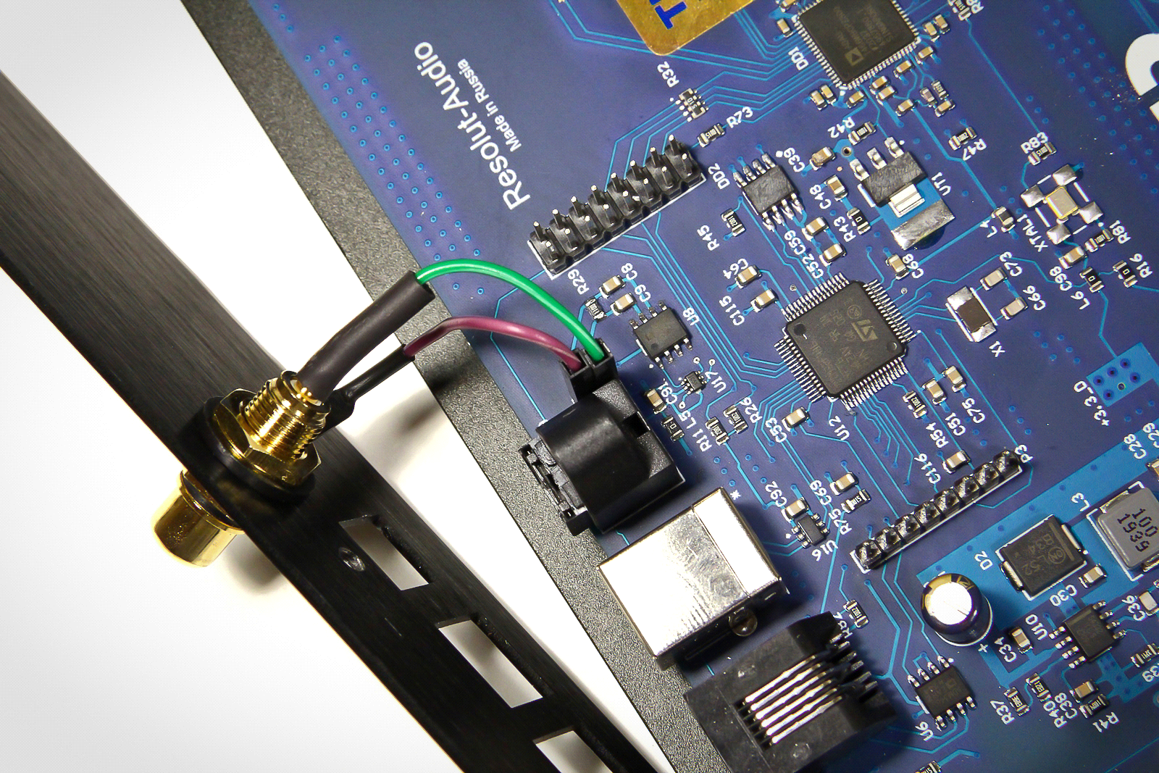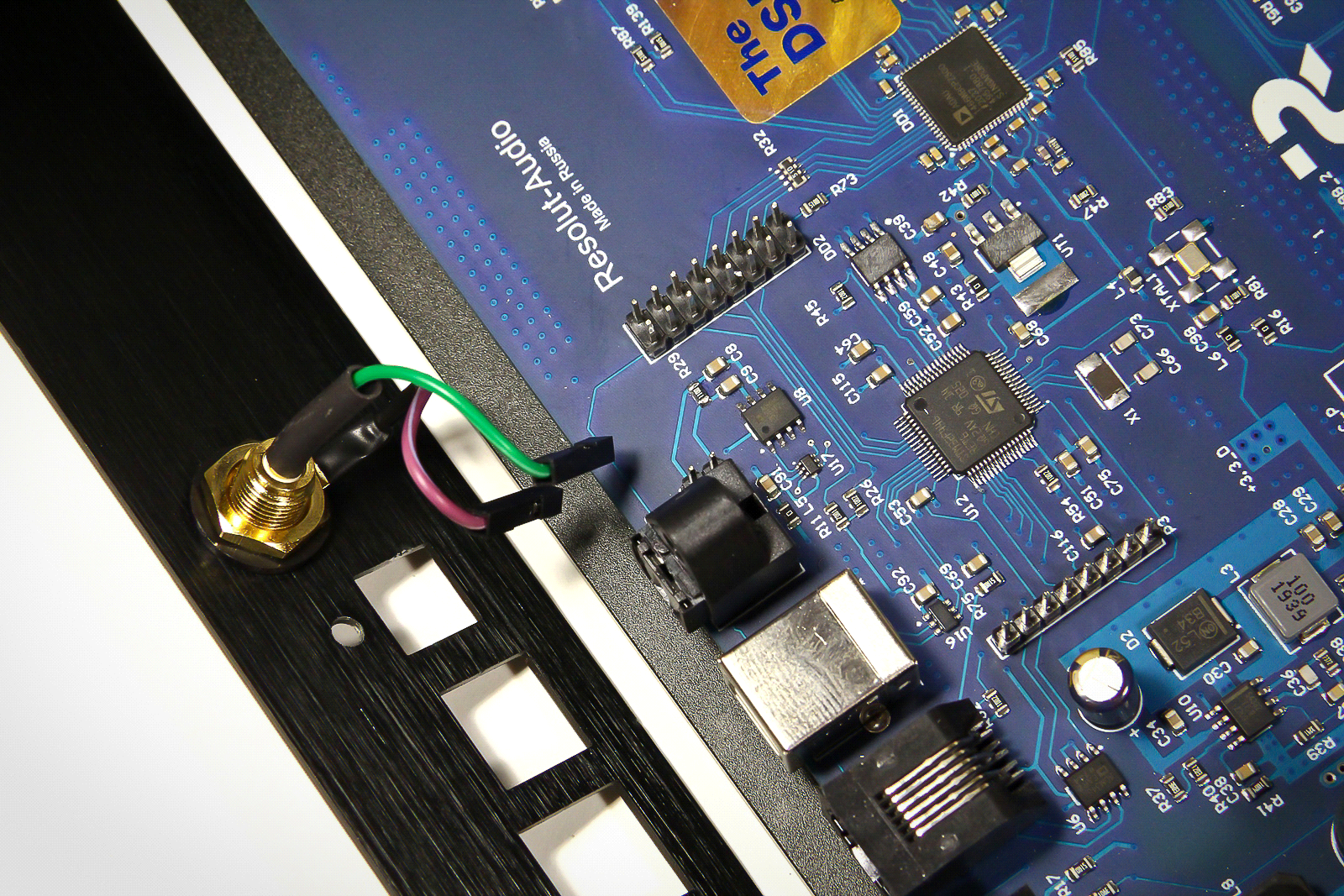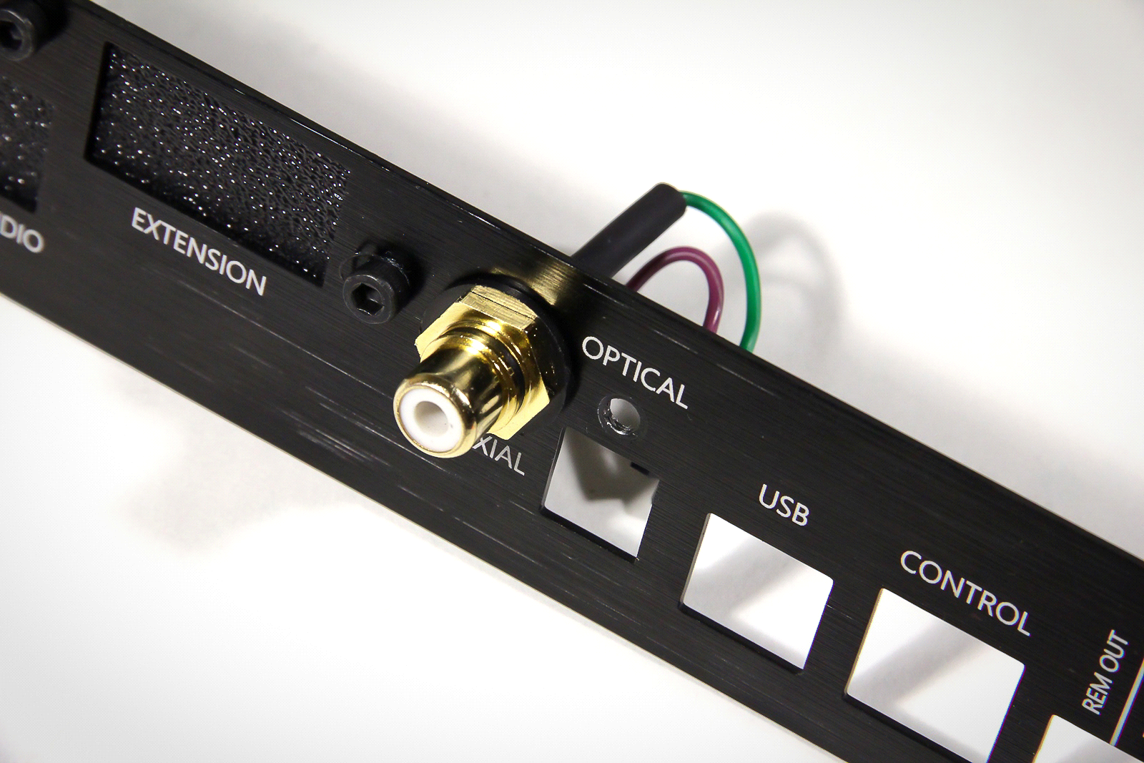

Step 3. Put Resolut A-IN module as on the photo. Make sure that connector on module are connected pin to pin to header on the board.

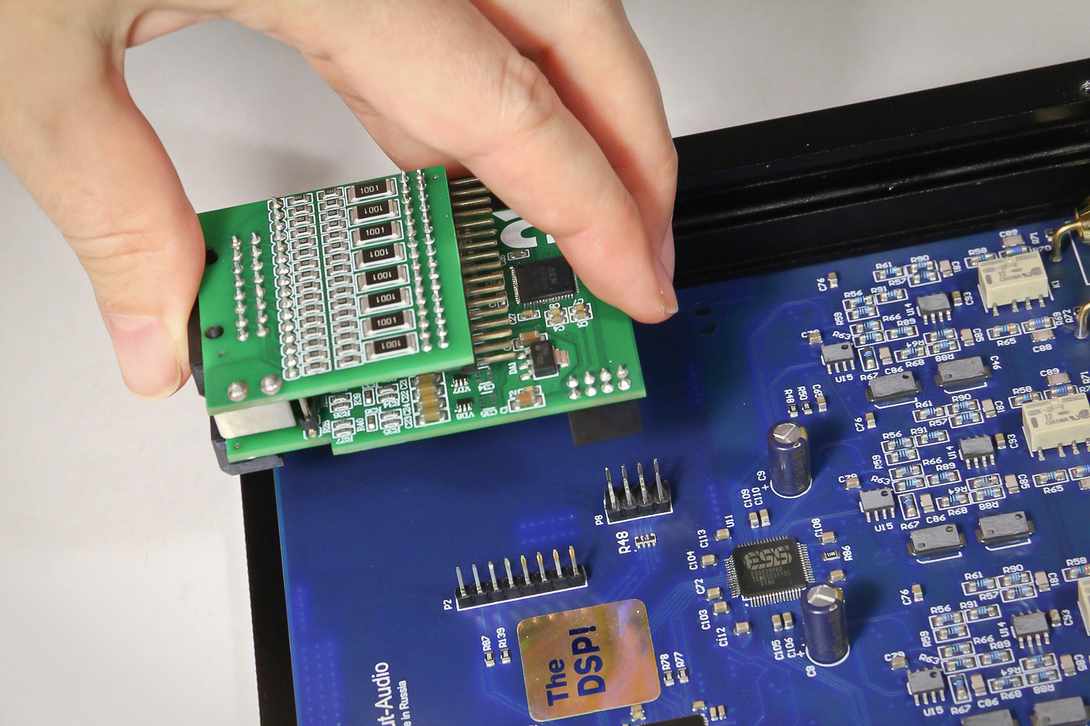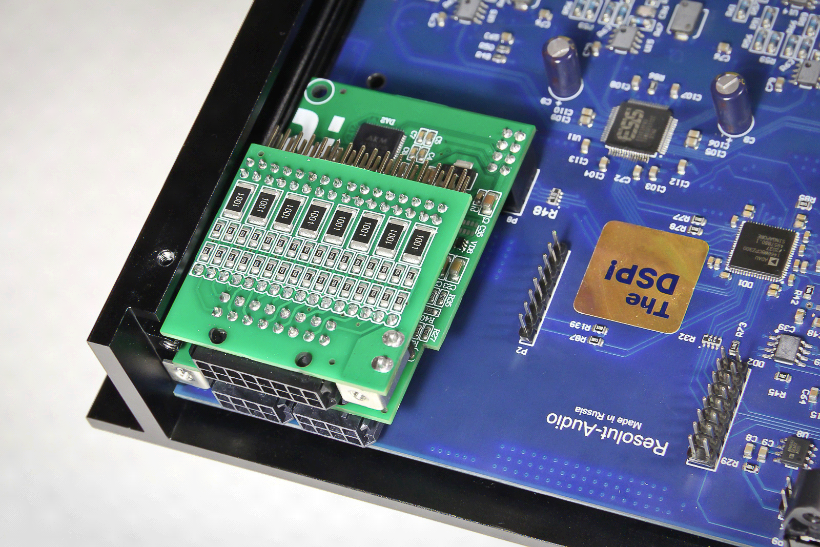

Step 4. Replacement panel has holes for additional modules, closed by plugs. Remove plug from ANALOG INPUT holes, stow new panel on processor's corpus. Do not forget to connect digital coaxial input to processor's board.

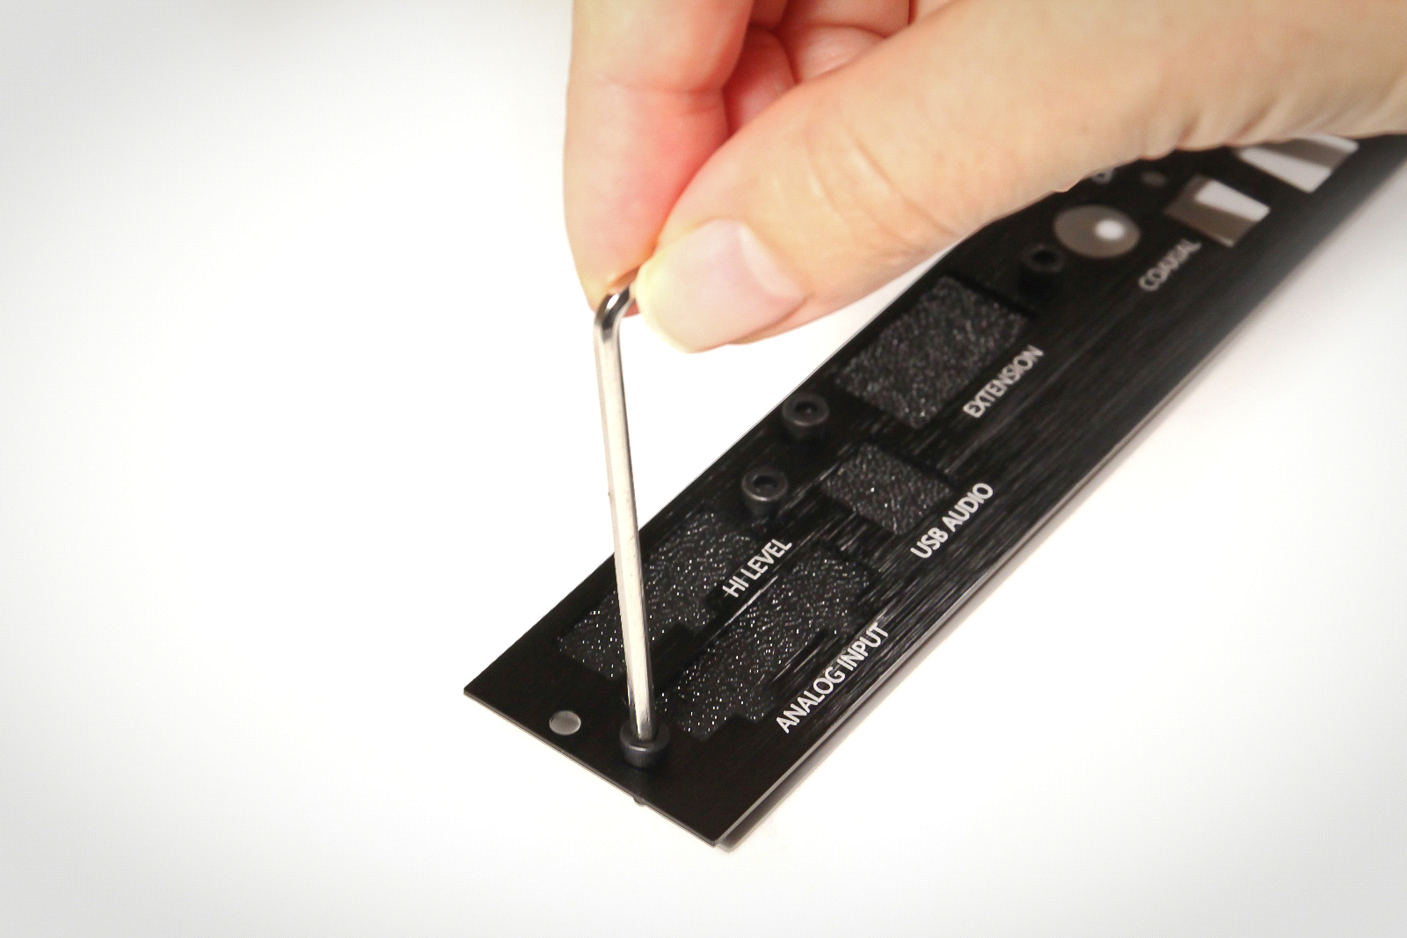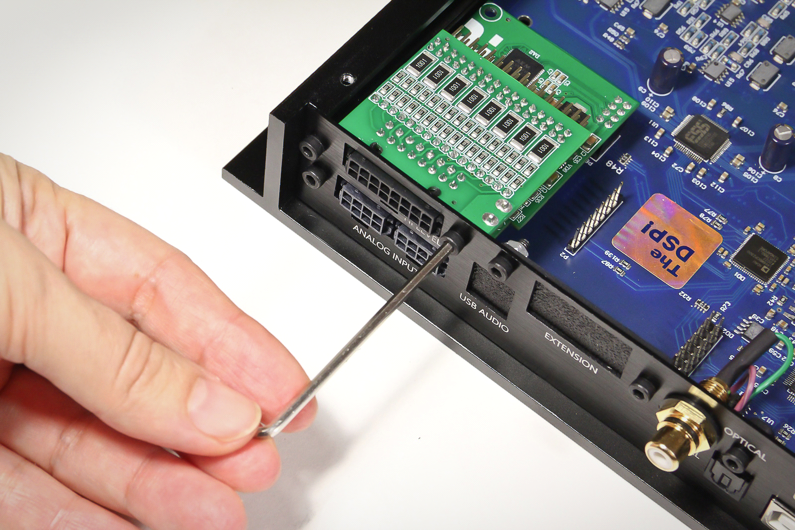

Advice. Don’t throw away removed base panel and plugs from replacement panel. If necessary to change processor's configuration by installation/removal of optional modules, you can return plugs on their places or install again base panel.

Step 5. Return the top cover on corpus. After installation module must looks like:

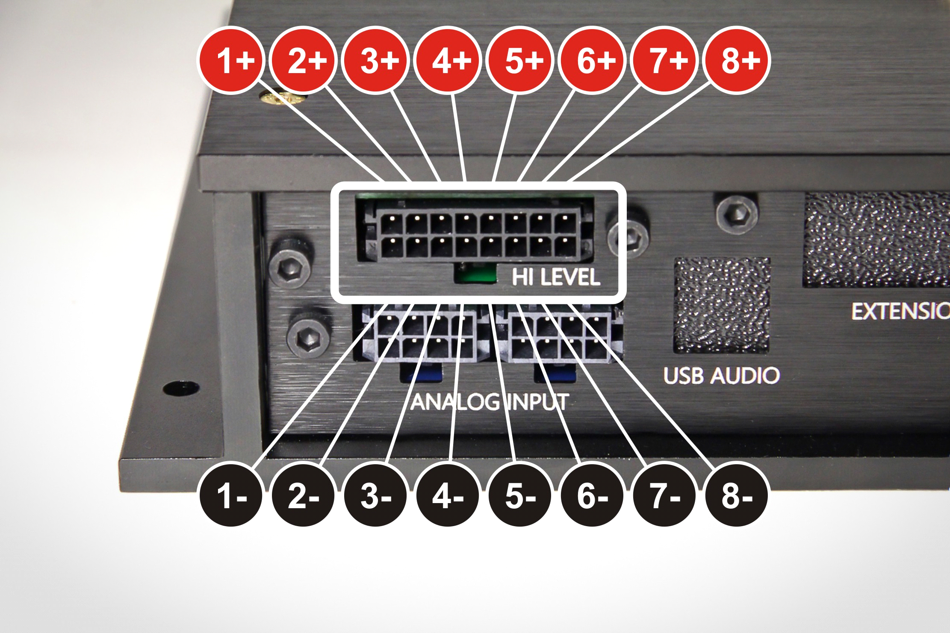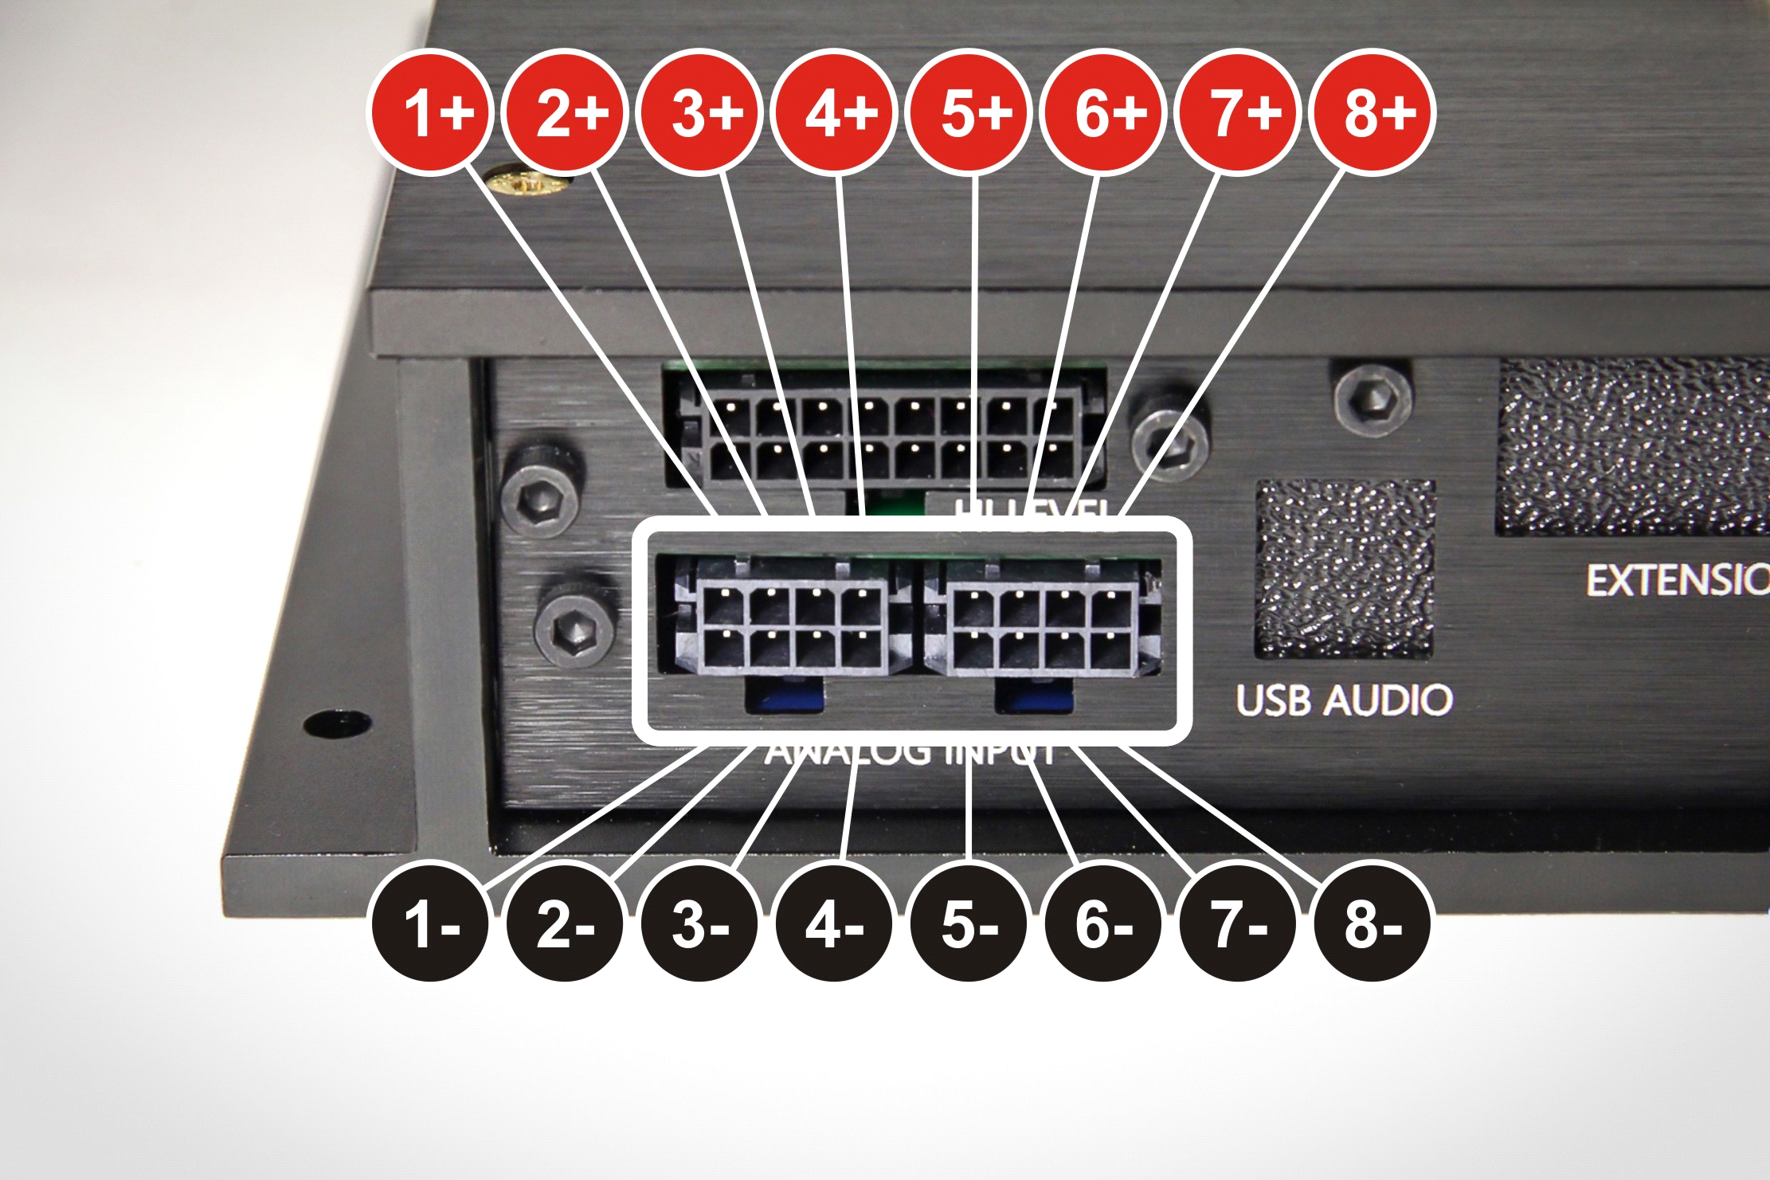

Step 6. Go to official web-site resolut-audio.ru. In tab «Downloads» you can find latest updates of Resolut DSP Tool, firmware and plugins for different modules. Download and install Resolut DSP Tool and file of plugin for module Resolut A-IN.

Step 7. Connect the processor to PC, open it and run Resolut DSP Tool. Be sure that processor connection is normal. Following the manual of software update (like described in "User manual"), install to processor suitable plugin for working with Resolut A-IN module.

Congratulations! You processor Resolut now is equipped with analog inputs!

